Ex.N.3: Spectrum Analysis of Sub-1 GHz, Mid-band & mmWave by Plotting Propagation Loss.

AIM:
To analyze the propagation loss characteristics of different frequency bands (Sub-1 GHz, Midband, and mmWave) in wireless communication systems and compare their performance over varying distances using MATLAB.
Objective :

- To compute the Propagation Loss (dB) for Sub-1 GHz, Mid-band, and mmWave frequency ranges using standard path loss models.
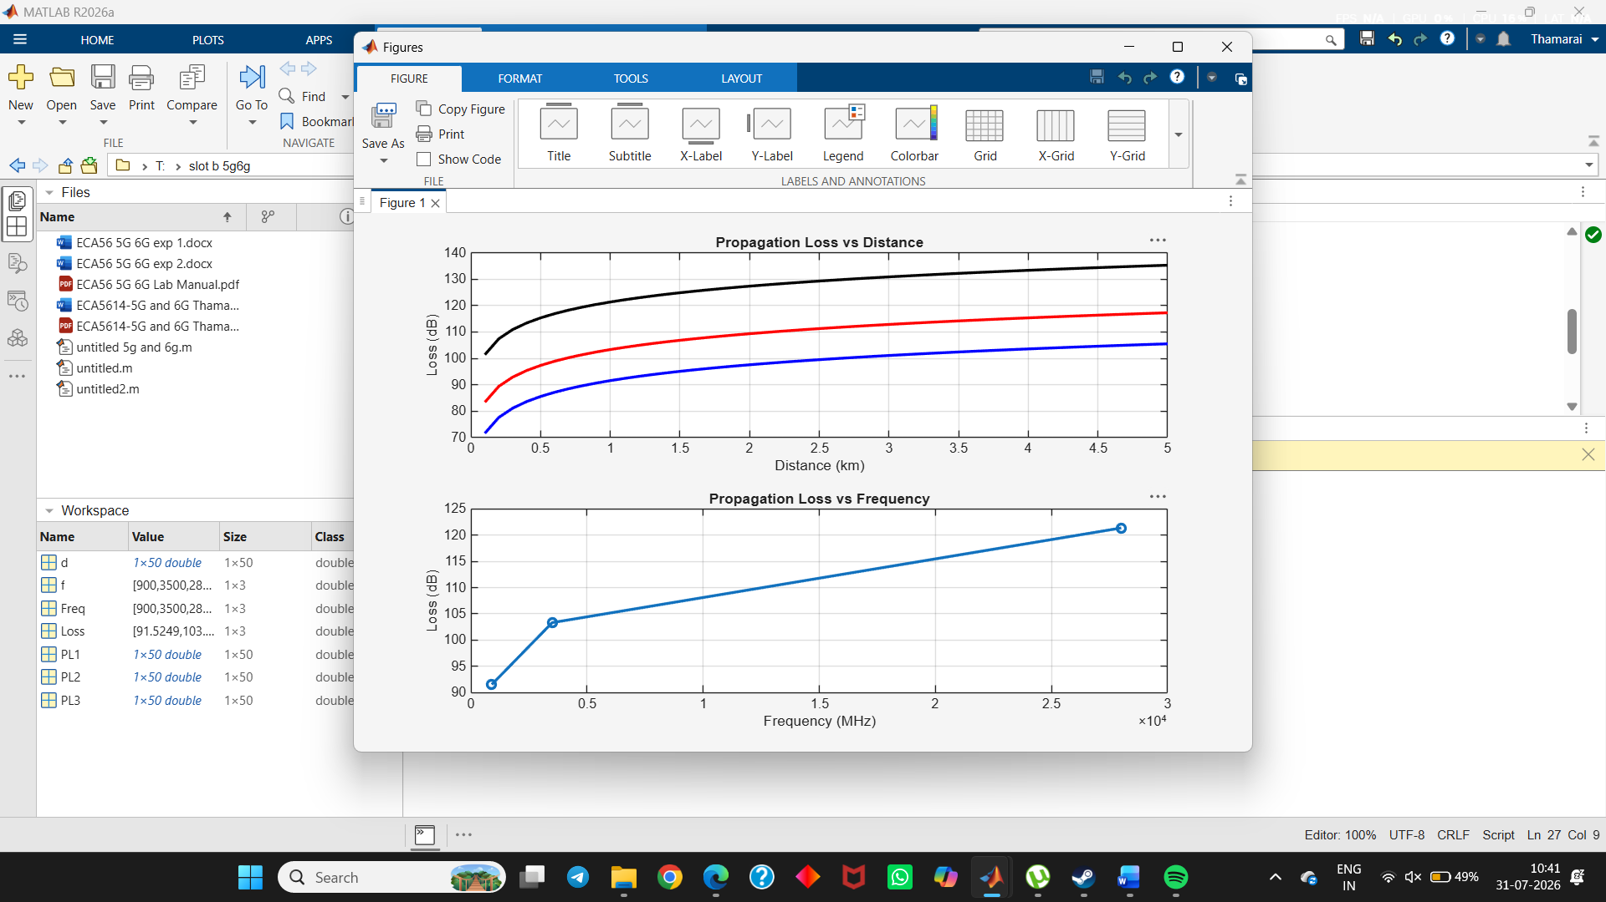
- To evaluate the impact of different Operating Frequencies (GHz) on signal attenuation and coverage performance.
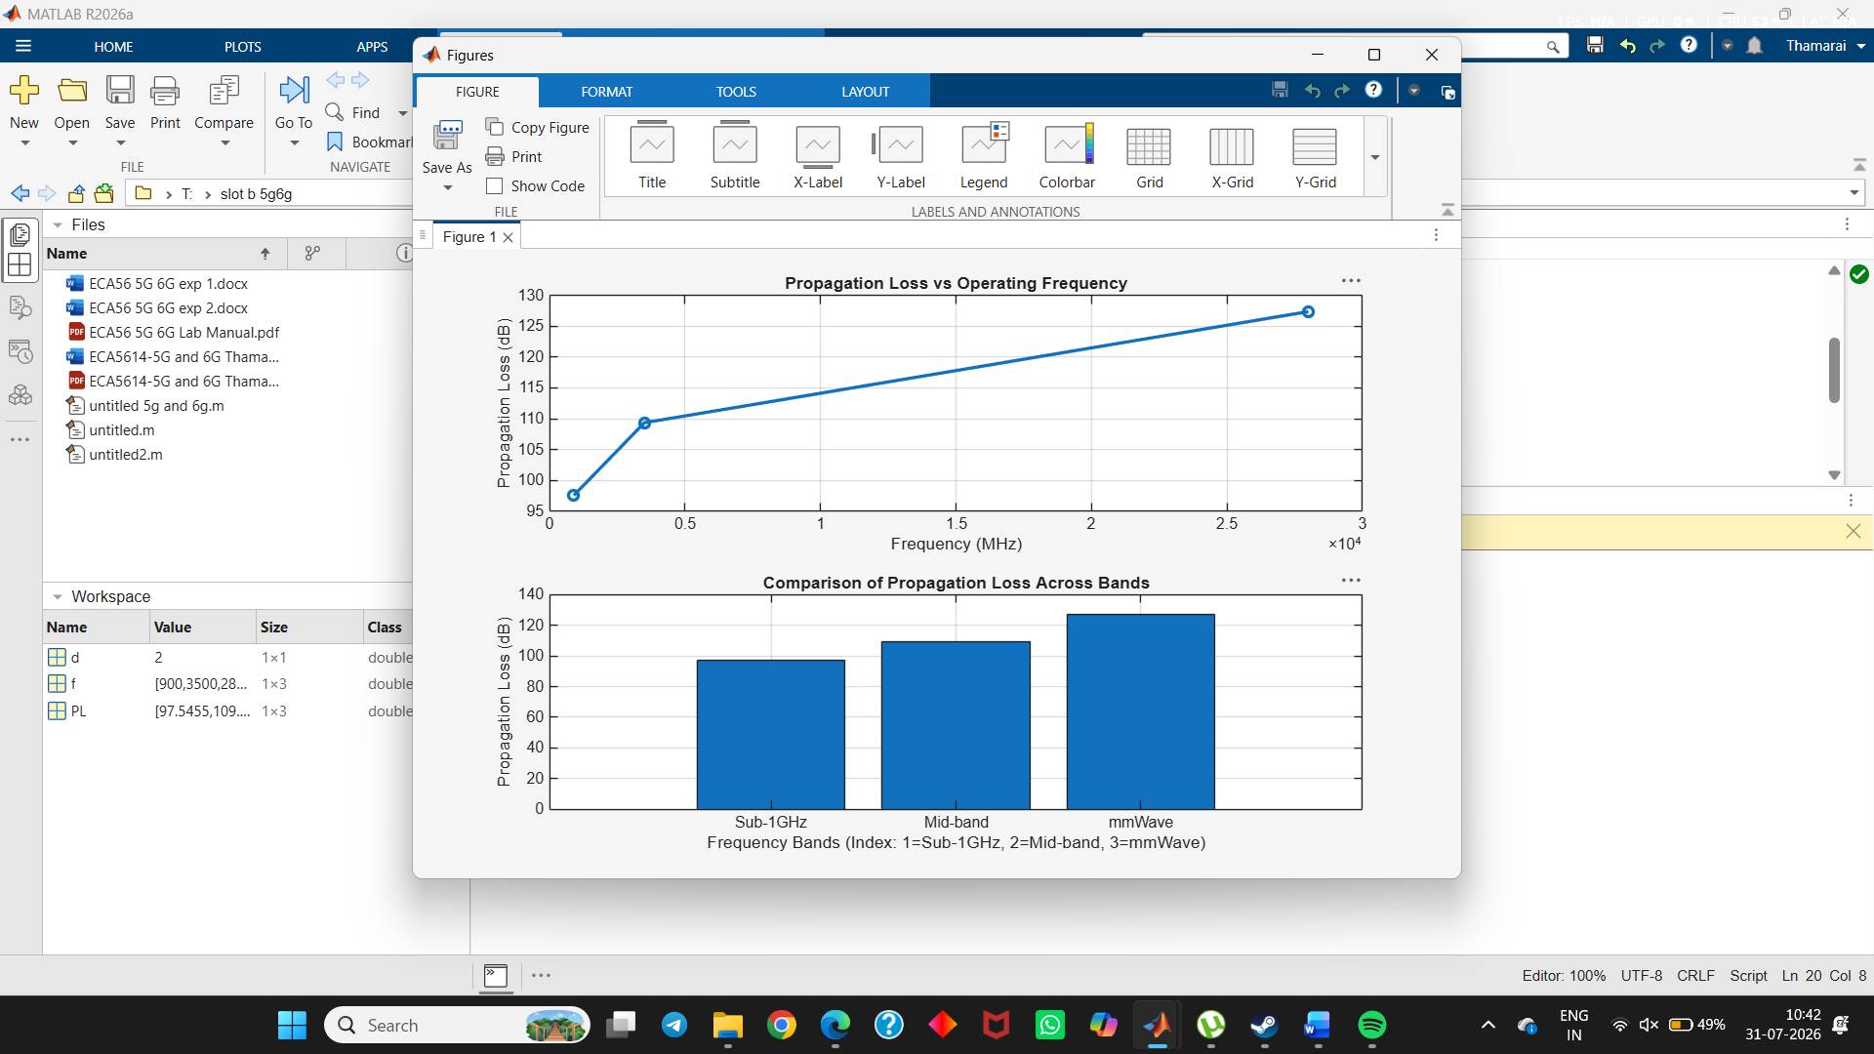
- To analyze how Communication Distance (km) affects propagation loss across different spectrum bands.
